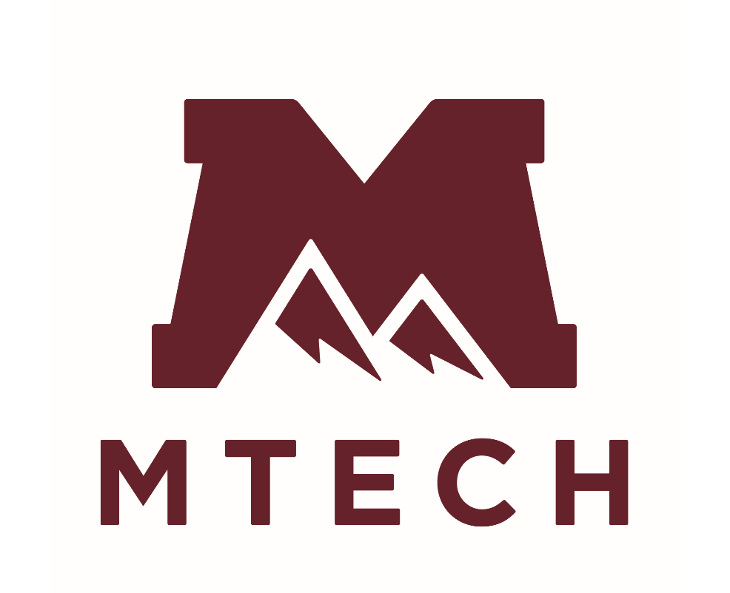 | 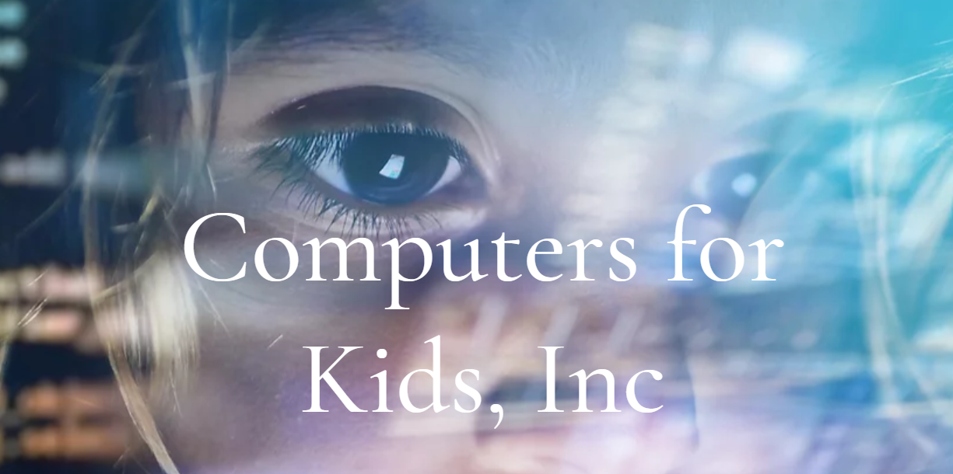 |  |  | 

Earth Day—Invest in our Planet
E-Waste and Computer Clean Up
Lehi, Utah

Frequently Asked Questions

Objective:
Hold an eWaste and Computer Clean Up for Earth Day 2022 in Lehi Utah.
Business Clean Up | Friday 10 June 2022
Community Clean Up | Saturday 11 June 2022
Friday Times: | 9am to 3pm
Saturday Times: | 9am to 3pm (until 7pm for volunteers)
Location: | Mountainland Tech College, Ashton Boulevard Lehi 84043
Drive Through: | Donors must remain in their vehicles
Vision:
Establish an annual E-Waste and Computer Clean Up for businesses and residents in Utah.
Goal:
Reduce E-Waste in landfills, refurbish and repurpose high performing devices for those in need and ensure that E-Waste is recycled responsibly and ethically.

Message:
Our message for businesses and the residential community is:
- Help Restore our Earth.
- Repurpose surplus technology for kids and students in need.
- Keep e-Waste out of our landfills.
- Recycle e-Waste responsibly and ethically.

What are the COVID Protocols?
For Security of donations and for COVID protocols, we ask that all donors remain in their vehicles.
- Volunteers will collect your details to complete an IRS donation slip.
- Volunteers will guide you to the drop off / donation point.
- Volunteers will take your donation from your vehicle.
- We ask that the drivers of vehicles wear masks.
- All volunteers will wear masks and sanitize regularly.

Where do I go when I arrive at MTECH?
You can enter MTech from Ashton Boulevard or Triumph Boulevard. Head toward the northern carpark where the MTECH trucks are near the big warehouse hanger. Watch for volunteers to guide you.
Who collects the e-Waste?
Computers for Kids is a Boise-based non-profit and is one of the USA’s leading technology refurbishers and has distributed over 50,000 refurbished computers to at risk and low-income kids and students nationwide over the past 19 years.

About Computers for Kids:
Computers for Kids has recycled more than 20,000 tons of e-Waste over the past 19 years. They have distributed over 50,000 refurbished computers and devices to kids nation-wide. More information here: www.cfkutah.org

What happens to the data on hard drives?
Computers for Kids has over 20 years of experience in securely erasing data. Their commercial entity, Secure Erase is one of only 3 USA companies certified and licensed to erase all data from every hard-drive no matter the device or where it came from (computers, tablets, phones, copiers etc).

Every hard drive is erased
Every hard drive will undertake the process of secure erase and drives that do not meet strict performance standards (after erasing) are re-erased before being shredded.

Need more Confidence?
Computers for Kids (Secure Erase) is contracted by companies, government entities and hospitals across Idaho to manage e-Waste and computer refurbishing programs.

Contact Molli Wingert from Computers for Kids to request a contract and meeting to discuss compliance with IT and Legal departments.

What will it cost to donate my e-Waste?
There is no cost associated with donating your e-waste during this clean-up campaign.

Can I receive an IRS donation slip?
Donation slips can be provided for donations.

What is e-Waste?
Essentially, e-Waste is end-of-life electronics. It can be just about anything that is battery operated or power operated. Examples are computers, monitors, printers, cell phones, iPads, tablets, devices, cameras, radios, fans, microwaves, toasters, vacuums. View list of what can be recycled

What is not collected?
The e-Waste clean-up will NOT take CRT TVs and computer monitors. These TVs and monitors need to be ‘de-manufactured’ and disposed of in line with strict environmental compliance standards.

What does CRT stand for?
CRT is a cathode-ray tube or a vacuum tube in which a hot cathode emits a beam of electrons that pass through a high voltage anode and are focused or deflected before hitting a phosphorescent screen.

What is a CRT TV?
A CRT television device uses cathode ray tubes and they contain heavy amounts of lead and toxic phosphor dust. They are considered ‘hazardous’ and there are significant environmental consequences when they are not disposed of responsibly. They need to be ‘de-manufactured’ which can only be done by certain certified hazardous e-Waste recyclers.

Where can I take CRTs in Utah?
The following recycling brokers in Utah can receive CRTs—they will charge a minimal fee to cover the cost of de-manufacturing and ethical recycling process:
- Recycle Utah, Park City
- Best Buys
- MTech Recycling
- Salt Lake Valley Landfill
- Summit County Landfill
What does your company or organization do with surplus technology?
Computers for Kids major partner, Micron Technology has donated more than 40,000 computers to Computers for Kids which has made a positive impact for children and students nation-wide to bridge the technology divide.

What does your company or organization do with your surplus technology?
Would you consider donating it for kids and students who need it?

Extending the lifecycle of technology
By reusing hardware, we are extending the lifecycle of the technology and reducing our environmental impact.

Which companies have donated in Utah?
Micron Technology has been a partner of Computers for Kids for 20 years and has donated over 40,000 computers to Computers for Kids. Micron Technology Utah donated their first 700 computers to Computers for Kids in October 2020 and we partnered with Mountainland Technical College (MTECH) Lehi Campus to distribute over 500 of those computers to kids and students in Utah in November 2020.

Donated in Utah Stays in Utah
Computers for Kids have committed to keeping the computers donated in Utah for Utah based kids and students.

Recycling benefits kids
Revenue from e-Waste recycling helps Computers for Kids provide scholarships for computers for underprivileged and low-income students and keep costs to a minimum.

Recyclers
Computers for Kids partner with certified / licensed R2 Recyclers who break down and recycle the components of the e-Waste such as: glass, plastics, metals and precious metals.

What is an R2 Recycler
There are currently two standards for electronics recycling. R2 stands for Responsible Recycling and is a standard specifically created for the electronics recycling industry by Sustainable Electronics Recycling International (SERI).

What is an eSteward?
There are currently two standards for electronics recyclers in the USA. One is called the e-Steward Standard for Responsible Recycling and Reuse of Electronic Equipment, known as eSteward.

Where does the eWaste go?
It may be dispersed to multiple USA locations depending on the by-product, but the waste remains in the USA and is not shipped to other countries.

Technology is disposable
Technology has become increasingly integrated into every aspect of our lives and the lifespan of devices is getting shorter—with most devices thrown away once the batteries die.

Why do we have so much e-Waste?
Companies intentionally plan the obsolescence of their tech goods by updating designs, software and discontinuing support for older models—which usually makes it cheaper to buy a new product than to repair it.

Global Increase in technology
Globally, half of all households have internet access and over 5 billion people own cell phones. Over 416,000 cell phones are replaced each day.

Why should your house or your company recycle e-Waste?
To care for our planet, recycle e-Waste responsibly and ethically and keep hazardous e-Waste out of our landfills.

Why is e-Waste toxic?
There are a range of heavy metals in e-Waste such as mercury, lithium, lead, barium which can contaminate soil and leach into groundwater and eventually make their way into ponds, streams, rivers, lakes, and ultimately into food sources.

What makes up most of the e-Waste?
- Each year 1 billion mobile phones and 300,000,000 computers are sold.
- Everyday 416,000 mobile devices are discarded.
- The e-Waste generated in USA each year is the equivalent weight of 350 cruise ships.

Is there any value in e-Waste?
When 1 million mobiles phones are recycled it recovers:
- 20,000 pounds of copper
- 550 pounds of silver and
- 50 pounds of gold

How much e-Waste is generated each year?
- Our dependency on tech generated over 50 million tons of e-Waste in 2019.
- It is estimated e-Waste will grow to 57 million tons this year.
- In 2019, 53.6 million metric tons of e-Waste was produced which is more than 7.3 kilograms for every person on the planet.
- Global e-Waste is surging by 21% each year.
- The e-Waste generated in the USA will increase by 17% by 2022.
- $57 billion in gold and other components are discarded when not recycled.
Can my business or organization donate computers before June?
If your company or organization has bulk computers or e-Waste to donate before the Earth Day clean up event, contact Computers for Kids to arrange a collection.

Register at the link below and contact the head office on 208.345.0346 to arrange a collection (free of charge). You will need to provide the dimensions and weight of the load. Business bulk e-Waste registrations cut off June 1st, 2022:

https://www.cfkutah.org/business-earth-day-registration-pag

How can I volunteer?
Register at this link if you would like to volunteer.
https://www.cfkutah.org/volunteering

Who can I contact if I have questions?
Computers for Kids—Molli Wingert
208.345.0346 │cfk@cfkid.org, cfk@cfkutah.org

Texas Instruments Utah—Vanessa Perez
801.842.3043 │ v-perez1@ti.com

Mountainland Technology—Mark Middlebrook
801.830.1358 │ mmiddlebrook@mtec.edu

Thank you!
We believe our combined efforts during this event will be truly impactful on our community and help to Invest in our Planet.

We welcome your interest and support to join this collaborative effort to reduce, reuse and recycle e-Waste within our community to keep it out of our landfills.

We look forward to working together to make a difference for our children, our community, and our earth!

